Reading data from the html.

Steps:

1. Get the reference of the controls. 
2. Handle the button click

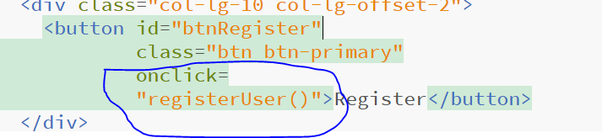

1. Write a method registerUser() in javascript.

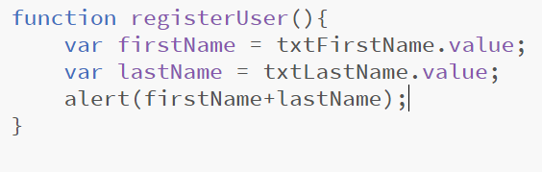

“txtFirstName.value” will give the value inside the text box.

“txtFirstName.id” will give the id of the textbox.

Like the above method we can access any property of a control.